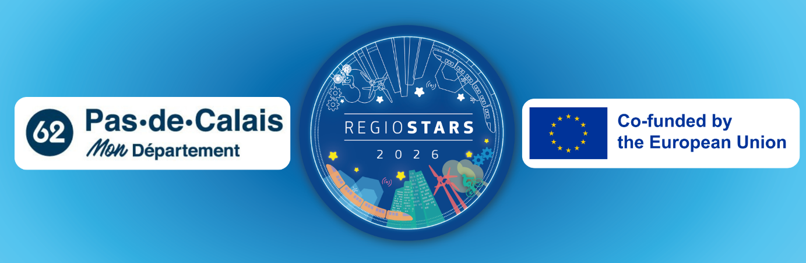

Integration through employment mission : Regiostars 2026 application

While northern France is experiencing high unemployment (9%) and poverty (18%) rates, the Pas-de-Calais departement is fully mobilized to support modest families. Its “Integration through employment mission” helps 46,000 households receiving the French minimum income allowance (“RSA”) find employment. Coordinating local and economic actors through innovative or digital platforms, this 50-person team helped 11,150 people return to work thanks to major construction and economic projects.
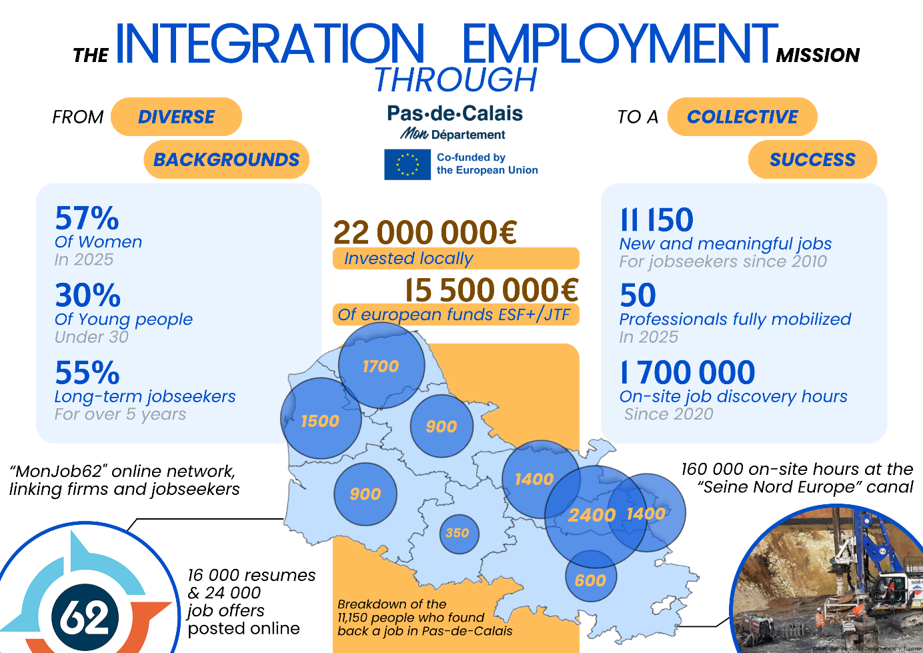

Summary of the project

Pas-de-Calais is one of the most populous departments in France, with 1.4 million residents. With high unemployment (9%) and poverty (18%) rates, the department is pursuing a proactive policy aimed at sustainable social and professional integration.

Created in 2008, the “Integration through employment mission” aims to build bridges between the business world and those seeking jobs : recipients of the minimum income (RSA) and young people under 26. Representing 52,500 people, the majority of them are women (57%), young people (23% under 30), and long-term job seekers : 55% have been unemployed for more than 5 years.

The mission introduces job seekers to the “hidden job market”—that is, sectors facing labor shortages that are little known, such as home care services. It also introduces them to major infrastructure projects in the Department that are potential sources of employment, such as the Louvre Lens museum, the Seine-Nord Europe Canal, and the Gravelines nuclear power plant.
Moreover, its digital platform “MonJob62” connects job seekers with businesses. This innovative system uses geolocation and matching technology to connect posted job openings with the profiles of job seekers.

Its 50-person team is spread across a former mining region, coastal cities, and the countryside, each region having different contexts and difficulties. While its 14 specialized advisors maintain ties with businesses and the “hidden job market”, 26 coordinators are responsible for regional coordination (coordinating local integration stakeholders) and regional development (engaging job seekers in major regional projects). They are supported by 1 department head, 1 Director of Major Projects, and 8 research officers.

Thanks to its innovative tools and its dense economic and social network, more than 11,150 RSA recipients and people under the age of 26 have returned to work.

How the project contributes to economic, social and territorial cohesion

While fostering links between regional and supra-regional economic and insertion actors and job-seekers ; the mission developed an ecosystem of actors that contributes to territorial, economic and social cohesion.

First of all, the mission contributes to the implementation of major supra-regional projects : maintenance of protected natural areas along the coast, renovation of mining towns, and construction of the Grand Canal linking Paris to northern France and then Belgium. These projects create jobs, connect regions and isolated areas and enhance their attractiveness, while staying committed to the environment, youth and social cohesion.

Moreover, the Pas-de-Calais is experiencing higher poverty rates compared to French and EU averages, with 1 person out of 5 considered at-risk-of-poverty (18,1%). Supporting professional integration means fostering cohesion : behind every person who finds a job is a new worker, a new consumer or even a potential future investor. For example, an innovative partnership with temporary staffing agencies was established in 2014, enabling the creation of temporary employment integration contracts, thus supporting the local economy.

Thirdly, on a more personal level, self-esteem and self-image can be significant barriers to returning to work and job searching. Believing oneself to be ineffective or having a negative self-image leads to withdrawal and avoidance behaviors. Those who are the most successful for professional reintegration are those who organize all the different spheres of their life : professional, social or community-based, and personal (taking care of one’s health, having a hobby). The Mission drew inspiration from these observations to develop innovative support programs and initiatives linking professional, socio-professional and social dimensions, such as the Employment Coaching and Youth Coaching.

The local and regional impact of the project and its results

Since its creation, the project has supported 11,150 job creations, including 1,450 permanent contracts. It also has organized 380 “Les Clés Pour Réussir” events (annual highlights where job seekers and employers connect) which have welcomed over 7,100 participants. Moreover, 1,600 beneficiaries had the opportunity to participate to 1,7 million hours of job-discovery and mentoring on local projects. The latter are numerous, and the most recent ones have had a significant local and regional impact.

The Seine-Nord Europe Canal aims to connect Paris to northern France. It represents an investment of more than 7.3 billion euros across six departments, including Pas-de-Calais. Since 2020, more than 200 participants have completed 160,000 hours of work on the project.
The “commitment to the Revitalization of the Mining Basin” aims to renovate former mining towns, representing more than 23,000 housing units at the regional level. Across the region, 24 mining towns have undergone thermal retrofits, and their communal spaces (parks, gardens) have been renovated. Since 2017, 1,400 people have completed 836,000 hours of work.

The Department has also been asked to participate in more local projects.
The “High-Level Service Buses” is an intercommunal project involving electric, hybrid, and hydrogen-powered buses. Since 2019, the initiative has provided training for 120 bus drivers, and nearly 70% of the participants were hired following the initial training sessions.
Moreover, fiber-optic infrastructure is rapidly expanding, and telecommunications operators started operating in the region. Since 2016, nearly 110 people have been trained in these areas and hired for these projects. They now hold permanent positions within these organizations.
Finally, the gas distribution network throughout Pas-de-Calais has also brought in unemployed individuals to train and subsequently hire them. Since 2019, 1,700 candidates have been placed with 300 companies, leading to nearly 500 hires.

An innovative and impactful project

Since 2008, the Department has adopted a proactive and innovative approach to promote access to employment for the most underprivileged groups.
On the one hand, the department has deployed a team of advisors specialized in employment integration, supported by a team coordinating the regional and partnership-based network for these groups. For example, this network has made it possible to organize the “Clés Pour Réussir” initiative. On the other hand, several tools have been developed to provide ever-better support for their work.

To facilitate connections between the beneficiaries and hiring companies, a digital platform, “MonJob62,” was launched in 2018 to connect job seekers with employers. Furthermore, since 2021, the “Mobilité 62” platform has been assisting participants with their mobility challenges (the number one barrier to returning to work) by providing bicycles and offering assistance for obtaining a driver’s license. Finally, since 2022, the “Autonomie 62” platform has brought together all stakeholders and professions in the personal care sector.

Furthermore, on-the-job immersion within major regional construction projects also represents a major innovation. Pas-de-Calais is a pilot experiment where technical innovation, economic development, and social inclusion come together : the construction of a nuclear power plant, the establishment of the Louvre-Lens museum, and the development of waterways or urban planning.

The financial sustainability of the project

In a challenging social and economic context, the Department leads initiatives aimed at social and professional integration. To this end, it funds the Active Solidarity Income (RSA) and the “Integration through employment mission”, as well as numerous partner organizations to facilitate access to employment.

European funding has enabled the Department to expand its projects, the mission in particular, co-funded since its creation. After 18 years of partnerships, the organization has received €15.48 million from the ESF, ESF+, and FTJ, for a total investment of €22.12 million. These partnerships are part of a broader framework: the local government invests more than €316 million annually in social and professional integration.

While the national economy is facing challenges and state support to local governments is shrinking, the Department continues to innovate and develop new projects for its citizens. Thanks to its experience and innovative policies, the Department is able to build on its successes to adapt to this changing environment.

How citizens and actors of civil society are involved in the development and the implementation of the project

Working closely with the citizens, the associations of the region are a vital actor in the network of stakeholders involved in the initiative. On the one hand, they provide personalized support to beneficiaries by working with them to develop individualized plans for returning to work. For example, the network has 500 case managers from municipal social action centers who provide local support. On the other hand, they facilitate access to employment through specialized support and a variety of integration projects: construction, public works, and landscaping.

Furthermore, citizens were consulted in developing this proactive departmental policy to establish a mandate that was subsequently implemented on the ground, notably through the mission. Other local governments are also involved in the initiative, such as the unprecedented partnership established in 2018 with the Hauts-de-France region regarding training for RSA recipients (french minimum income allowance).

How this project could be transferred to other regions

As a testament to its vitality, the initiative has been inspiring projects throughout northern France. As early as 2014, the Nord Department drew inspiration from it for its inclusion platforms, designed for job seekers. And since 2019, the mission director in charge of major projects has been coordinating the “Canal solidaire,” the employment integration component of the Canal Seine Nord Europe, for the five departments of the Hauts-de-France region.

Thanks to its experience, the project could also be replicated in other regions and for other domains. Indeed, the partnership forged with temporary staffing agencies, or the one focused on major infrastructure projects, could inspire new initiatives. These could be presented through the “Idéal co” information network or disseminated more widely thanks to partnerships, “best practices sharing” webinars and meetings between policy-makers or between those in charge of implementing them.

